Global Sales Data Analytics

A PROJECT REPORT

Submitted by

Arun.K

Kishore.P

Chella Kannan.K

Mahesh Raja.C

**TEAM ID**:**PNT2022TMID49356**

|  |  |
| --- | --- |
| **S.NO** | **TITLE** |

|  |  |
| --- | --- |
| **1** | **INTRODUCTION** |
| 1.1 | Project Overview |
| 1.2 | Purpose |
| **2** | **LITERATURE SURVEY** |
| 2.1 | Existing problem |
| 2.2 | References |
| 2.3 | Problem Statement Definition |
| **3** | **IDEATION &PROPOSED SOLUTION** |
| 3.1 | Empathy Map Canvas |
| 3.2 | Ideation & Brainstorming |
| 3.3 | Proposed Solution |
| 3.4 | Problem Solution Fit |
| **4** | **REQUIREMENT ANALYSIS** |
| 4.1 | Functional requirements |
| 4.2 | Non-Functional requirements |
| **5** | **PROJECT DESIGN** |
| 5.1 | Data Flow Diagrams |
| 5.2 | Solution &Technical Architecture |
| 5.3 | User Stories |
| **6** | **PROJECT PLANNING & SCHEDULING** |
| 6.1 | Sprint Planning & Estimation |
| 6.2 | Sprint Delivery Schedule |
| 6.3 | Reports from JIRA |
| **7** | **CODING & SOLUTIONING** |
| 7.1 | Feature 1 |
| 7.2 | Feature 2 |
| 7.3 | Database Schema |
| **8** | **TESTING** |
| 8.1 | Test Cases |
| 8.2 | User Acceptance Testing |
| **9** | **RESULTS** |
| 9.1 | Performance Metrics |
| **10** | **ADVANTAGES & DISADVANTAGES** |
| **11** | **CONCLUSION** |
| **12** | **FUTURE SCOPE** |
| **13** | **APPENDIX** |

# INTRODUCTION

If you want to achieve your sales goals month after month, then guesswork and intuition aren’t your best friends. You need to perform a strategic sales analysis and get cold, hard data.You will gain an understanding of the data

ecosystem and the fundamentals of data analysis, such as data gathering or data mining.

# Project Overview:

The automated, prospective analyses offered by data mining move beyond the analyses of past events provided by retrospective tools typical of decision support

# PURPOSE:

Regular sales data analysis provides an understanding of the products that your customers are buying and helps you dissect why they are behaving in a certain way. You can also find patterns in your lead conversions and drop offs.

Data mining tools predict future trends and behaviors, allowing businesses to make proactive, knowledge-driven decisions

Thousands of data points at your fingertips. Build, refine and analyse your audience in our intuitive platform. Monitor trends. Granular Global Analysis. 46 Countries. 17 Million Panelists. 40,000 Data Points. Create Bespoke Segments.

Sales analytics refers to the technology and processes used to gather sales data and gauge sales performance. Sales leaders use these metrics to set goals, improve internal processes, and forecast future sales and revenue more accurately**.**

# LITERATURE SURVEY

* 1. **Existing Problem:**
     1. Global sales process is way too long and don’t have enough leads.
     2. Leads are unqualified and wasting your effort on bad fit prospects.
     3. Spending too much time on low-value task
     4. The statement may include workflow bottlenecks,resources challenges or fundamental difficulties such as understanding a customer base
     5. Identify the key sales metrics you need, such as win rate and average deal size
     6. Use a tool (such as Pipe drive's CRM) to track this data as leads travel through your pipeline. Record this data in visual dashboards

# REFERENCES:

1. Han Jiawei, Micheline Kamber and Jian Pei, "Data Mining Concepts and Techniques" in , MK Publications, 2009.

[**https://scholar.google.com/scholar?as_q=Data+Mining+Concepts+and+Techn**](https://scholar.google.com/scholar?as_q=Data%2BMining%2BConcepts%2Band%2BTechniques&as_occt=title&hl=en&as_sdt=0%2C31)[**iques**](https://scholar.google.com/scholar?as_q=Data%2BMining%2BConcepts%2Band%2BTechniques&as_occt=title&hl=en&as_sdt=0%2C31)

1. M. Tennekes and E. de Jonge, "Top-down Data Analysis with Tree maps", Proceedings of the International Conference on Information Visualization Theory and Applications (IVAPP' 11), pp. 236-241, March 2011.

[**https://scholar.google.com/scholar?as_q=Top-**](https://scholar.google.com/scholar?as_q=Top-down%2BData%2BAnalysis%2Bwith%2BTreemaps&as_occt=title&hl=en&as_sdt=0%2C31)[**down+Data+Analysis+with+TreemapsHYPERLINK**](https://scholar.google.com/scholar?as_q=Top-down%2BData%2BAnalysis%2Bwith%2BTreemaps&as_occt=title&hl=en&as_sdt=0%2C31)[**"https://scholar.google.com/scholar?as_q=Top-**](https://scholar.google.com/scholar?as_q=Top-down%2BData%2BAnalysis%2Bwith%2BTreemaps&as_occt=title&hl=en&as_sdt=0%2C31)[**down+Data+Analysis+with+Treemaps&as_occt=title&hl=en&as_sdt=0%2C3**](https://scholar.google.com/scholar?as_q=Top-down%2BData%2BAnalysis%2Bwith%2BTreemaps&as_occt=title&hl=en&as_sdt=0%2C31)[**1" HYPERLINK**](https://scholar.google.com/scholar?as_q=Top-down%2BData%2BAnalysis%2Bwith%2BTreemaps&as_occt=title&hl=en&as_sdt=0%2C31)

1. P. Hoek, "Parallel Arc Diagrams: Visualizing Temporal Interactions", Journal of Social Structure, vol. 12, 2011.

[**https://scholar.google.com/scholar?as_q=Parallel+Arc+Diagrams%3A+Visual**](https://scholar.google.com/scholar?as_q=Parallel%2BArc%2BDiagrams%3A%2BVisualizing%2BTemporal%2BInteractions&as_occt=title&hl=en&as_sdt=0%2C31)[**izing+Temporal+InteractionsHYPERLINK**](https://scholar.google.com/scholar?as_q=Parallel%2BArc%2BDiagrams%3A%2BVisualizing%2BTemporal%2BInteractions&as_occt=title&hl=en&as_sdt=0%2C31)[**"https://scholar.google.com/scholar?as_q=Parallel+Arc+Diagrams%3A+Visu**](https://scholar.google.com/scholar?as_q=Parallel%2BArc%2BDiagrams%3A%2BVisualizing%2BTemporal%2BInteractions&as_occt=title&hl=en&as_sdt=0%2C31)

[**alizing+Temporal+Interactions&as_occt=title&hl=en&as_sdt=0%2C31"**](https://scholar.google.com/scholar?as_q=Parallel%2BArc%2BDiagrams%3A%2BVisualizing%2BTemporal%2BInteractions&as_occt=title&hl=en&as_sdt=0%2C31)[**HYPERLINK**](https://scholar.google.com/scholar?as_q=Parallel%2BArc%2BDiagrams%3A%2BVisualizing%2BTemporal%2BInteractions&as_occt=title&hl=en&as_sdt=0%2C31)

* 1. **Problem Statement definition:**

Problem statements are important to businesses, individuals and other entities to develop projects that states the challenges faced by your client.

You need to **analyze** the right kind of **sales** data for generating meaningful insights that positively affect your bottom line.

Sales analysis is vital for finding **weak spots and bottlenecks** in sales processes to collect and use sales data to achieve more sales goals.

# IDEATION & PROPOSED SOLUTION

* 1. **Empathy Map Canvas**

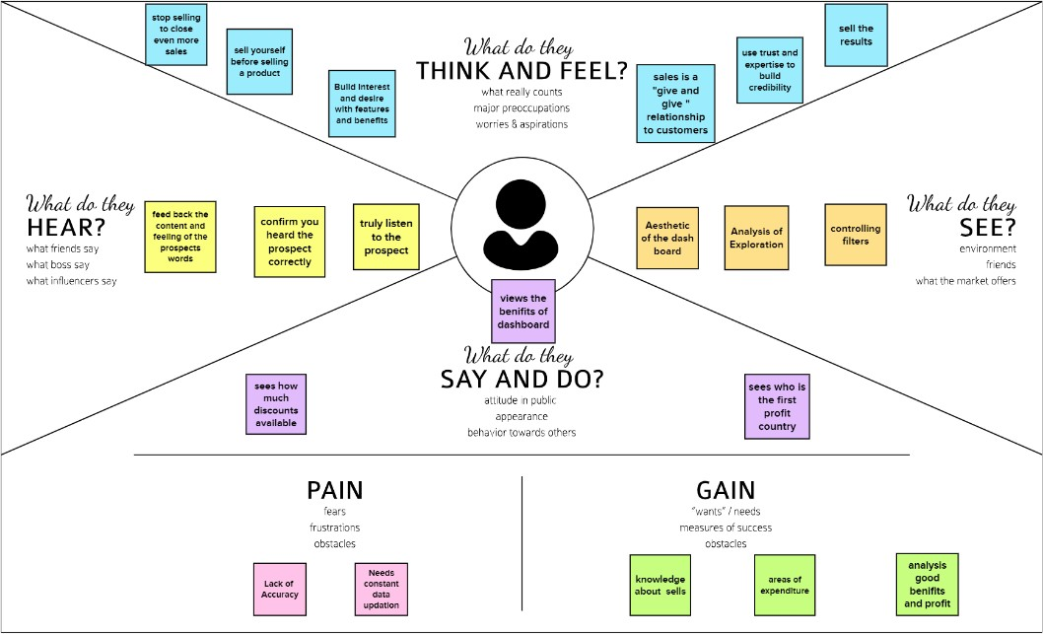

* 1. **Ideation & Brainstorming**

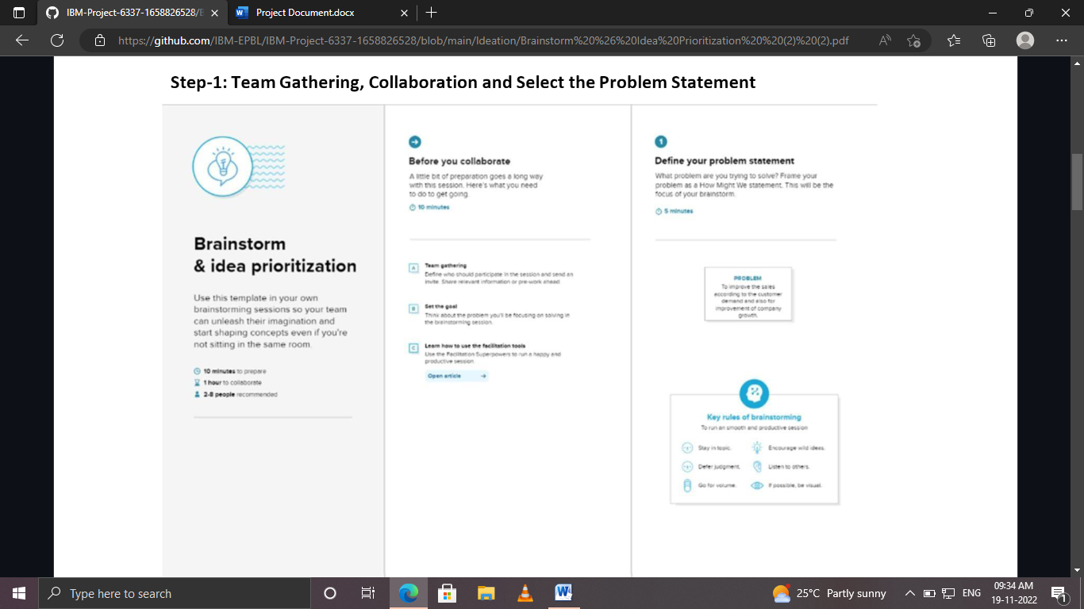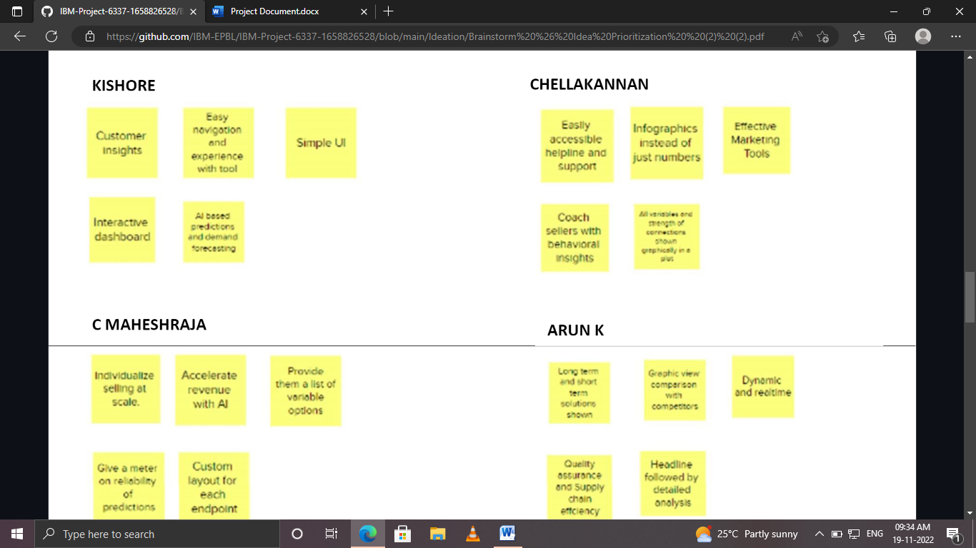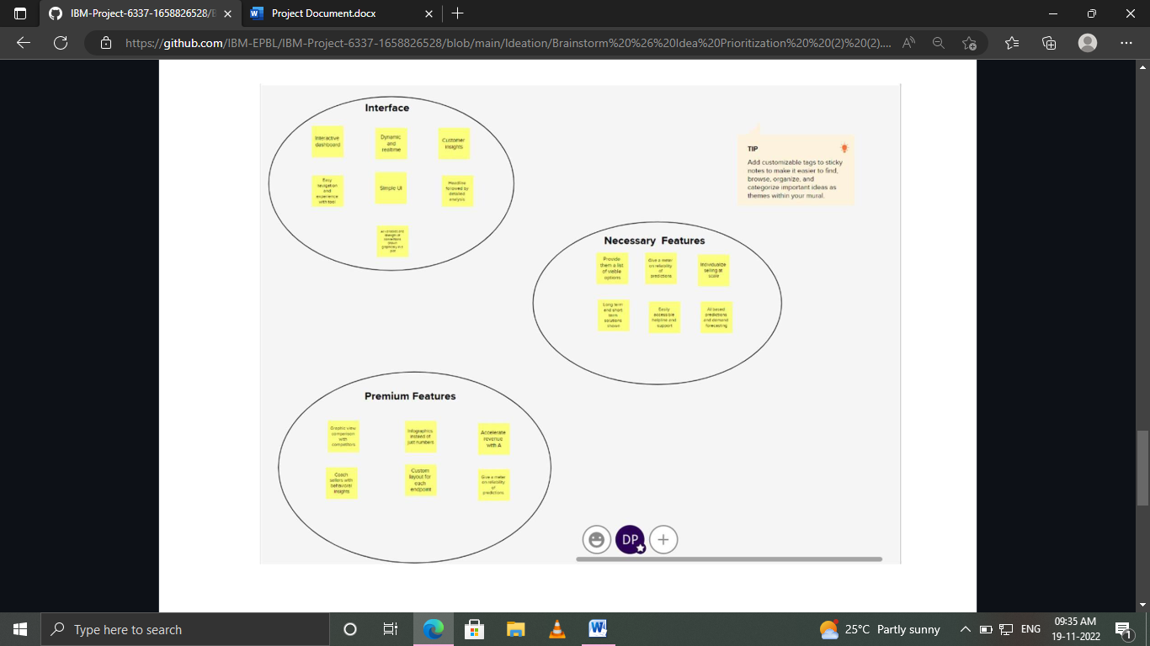

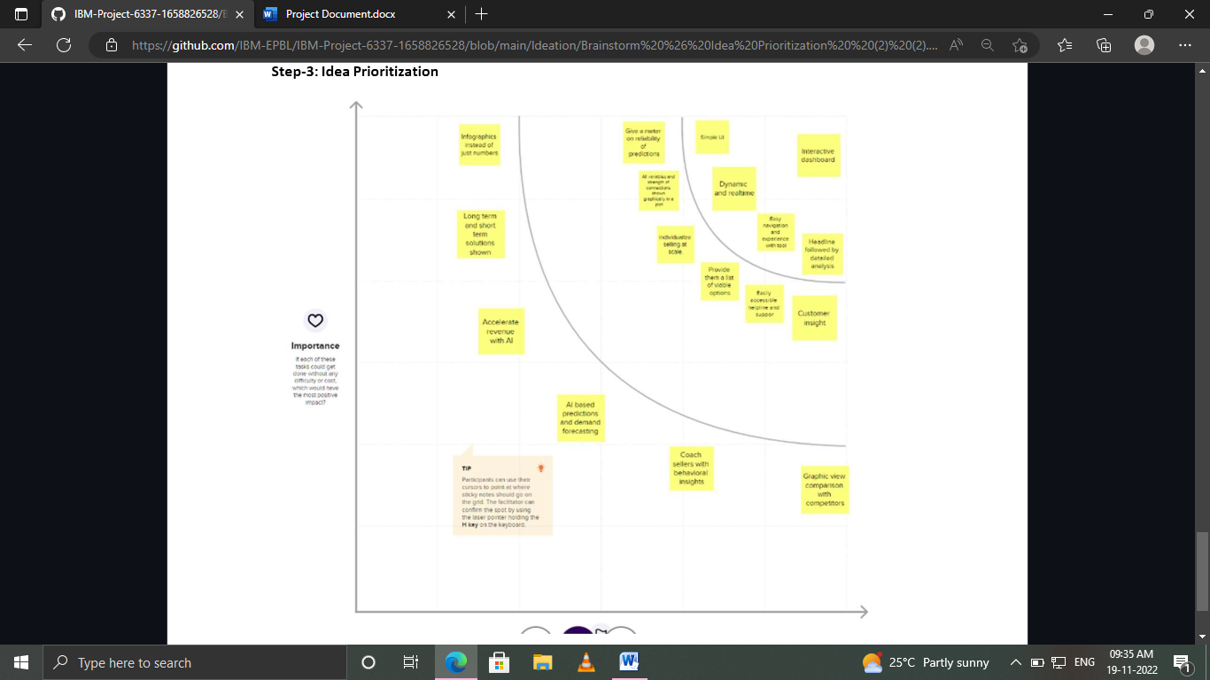

* 1. **Proposed Solution:**

|  |  |  |
| --- | --- | --- |
| **S.No** | **Parameter** | **Description** |
| 1. | Problem Statement (Problem to be solved) | Decision makers of E-commerce companies(User) need a way to comprehend raw data, analyze and make more informed business decisions. |
| 2. | Idea / Solution description | A powerful and easy-to-use sales analytics tool that  automates and visualizes sales trends to optimize  business outcomes |

|  |  |  |
| --- | --- | --- |
| 3. | Novelty / Uniqueness | * Interactive Dashboard and simple UI * Dynamic and real time analytics * AI based predictions and forecasting |
| 4. | Social Impact / Customer Satisfaction | * Visible profits driven by informed decisions * Optimize sales and marketing * Ability to react to competitor’s strategies |
| 5. | Business Model(Revenue Model) | Three tier pricing- Basic, Standard, Enterprise  Basic: Limited features targeting startups and individuals.   * Standard: Limited premium features. Target customers- Medium Scale businesses. * Enterprise with all premium features targeted at Large corporations |
| 6. | Scalability of the Solution | * More B2B customer services can be provided   alongside   * Usable by all customer facing companies and startups of all scale |

**3.4 Problem solution fit:**

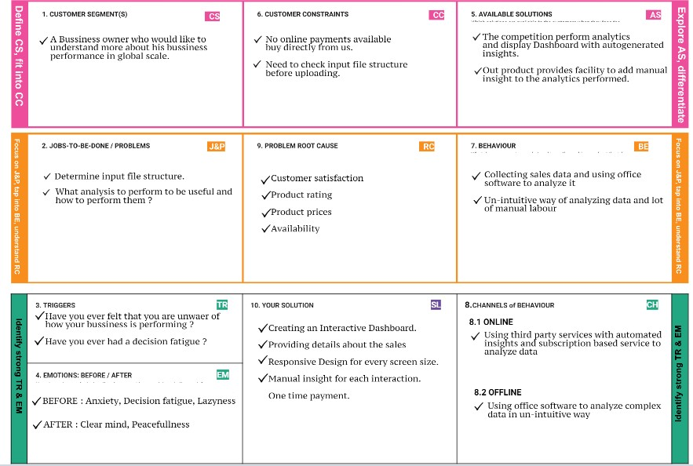

# Requirement analysis:

* 1. **Functional requirement :**

|  |  |  |
| --- | --- | --- |
| **Sl.No** | **Functional Requirements(Epic)** | **Sub Requirements(Sub Task)** |
| FR-1 | User Registration | Registration through Form Registration through Gmail Registration through Linked IN |
| FR-2 | User Confirmation | Confirmation via Email Confirmation via OTP |
| FR-3 | Data Entry | User should be able to enter sales data |
| FR-4 | Data Generated | Sales reports should be generated 24 hours |
| FR- 5 | Exploring Data | API interface to invoice system |

|  |  |  |
| --- | --- | --- |
| **FR No** | **Non Functional Requirement** | **Description** |
| NFR 1 | Usability | The web application usability now user  friendly.so easily understand user. |
| NFR 2 | Security | End to end encryption technique will be used our product |

|  |  |  |
| --- | --- | --- |
| NFR 3 | Reliability | The web application must have a  99.9%uptime |
| NFR4 | Performance | The home page should load within 1.5  seconds |
| NFR 5 | Availability | The web application must have a 99.9%  uptime |
| NFR 6 | Scalability | The web application will be compatible for  both windows&mac machines |

**4.2 Non-functional requirement**

**Project Design:**

**5.1.Data Flow Diagram**:

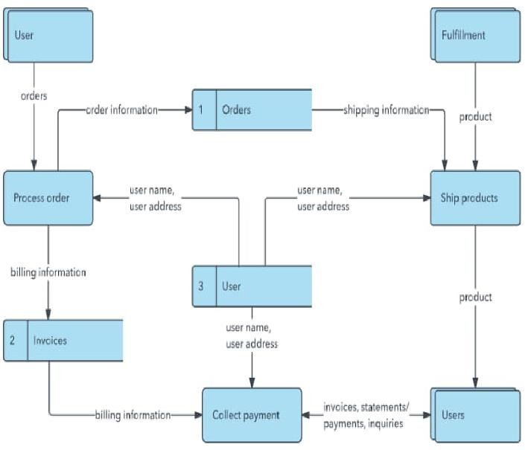

**5.2 Solution and Technical Architecture:**

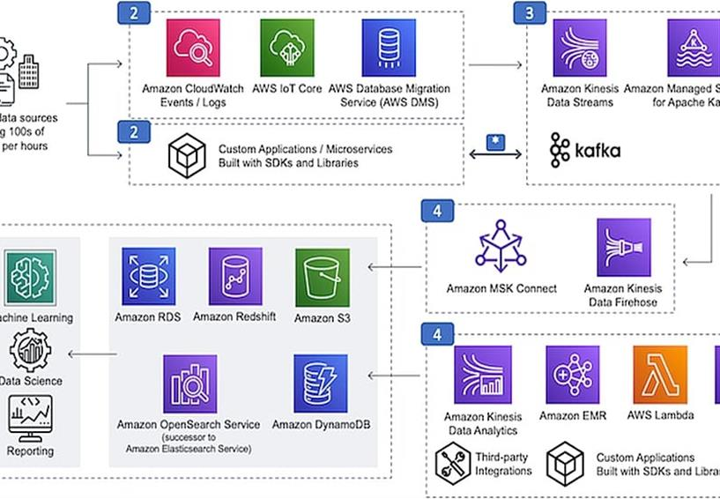

# Project Planning & Scheduling:

* 1. **Sprint Planning & Estimation**

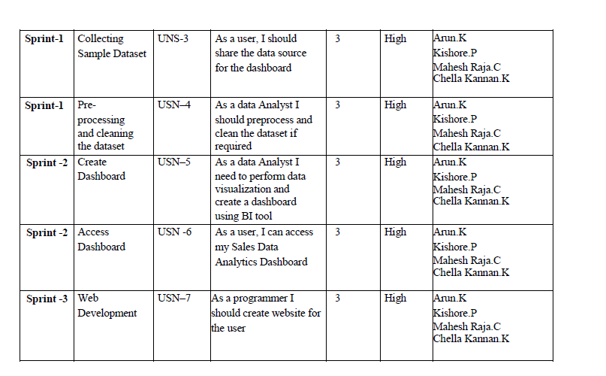

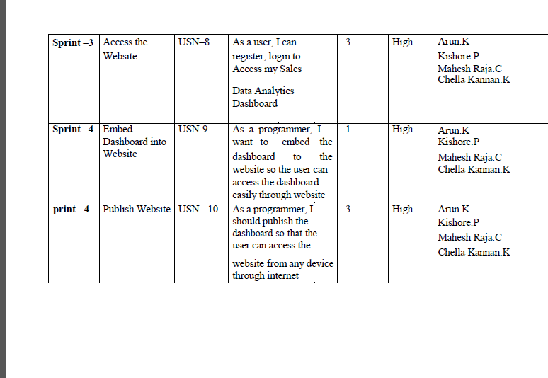

* 1. **Sprint Delivery Schedule :**

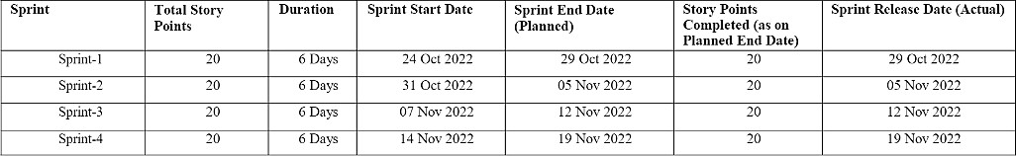

**Velocity:**

We have a 24-day sprint duration, and the velocity of the team is 20 (points per sprint). Let’s calculate the team’s average velocity (AV) per iteration unit (story

points per day)

# AV = Sprint Duration / Velocity = 20 / 10 = 2

# 

# Burndown Chart :

A burn down chart is a graphical representation of work left to do versus time. It is often used in agile software development methodologies such as Scrum. However, burn down charts can be applied to any project containing measurable progress over time.

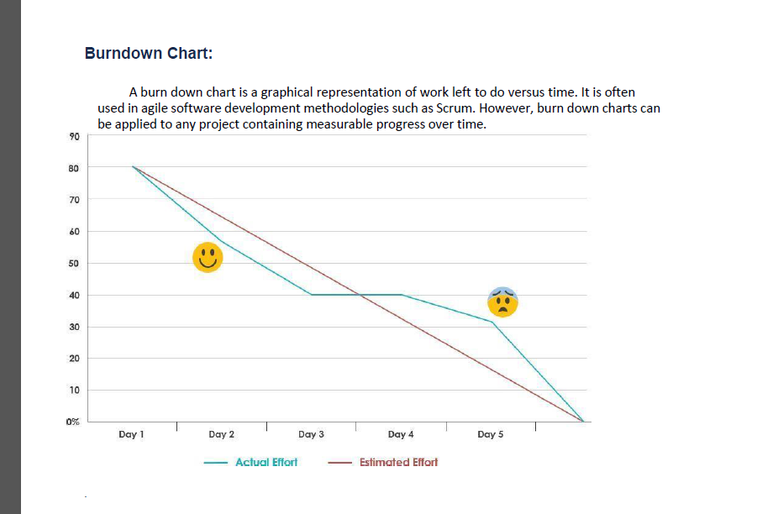

# Reports from JIRA :

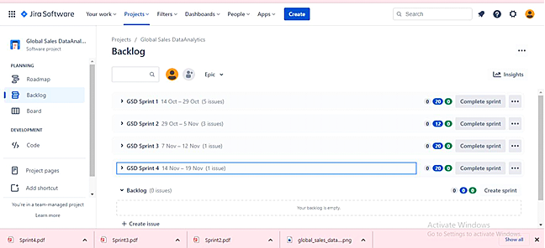

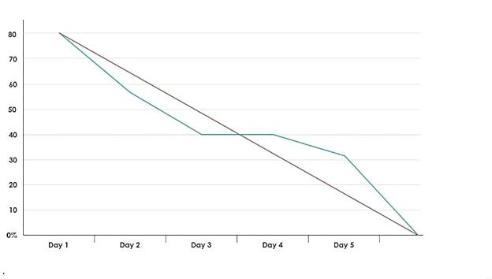**Burndown chart :**

# Road Map:

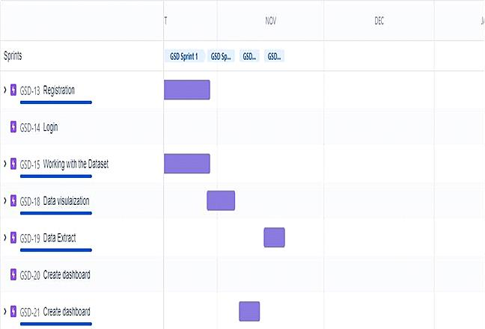

1. **Coding & Solution:**
   1. **Feature 1**

# Sales – Analysis:

This is an analysis of the sales data with particular focus given to how promotions and advertising translate into sales, in terms of both units sold and sales dollars.

# Different types of Sales Analysis

* + - Furniture company sales analysis HTML file
* Cereal Company Sales Analysis HTML file
* Financial Statement Analysis PDF file

# Analysis using R Shiny Dashboard

* Furniture company sales Dashboard R Shiny app

# Steps for Cereal Company Sales Analysis

1. Download the Raw Data
2. Analysis code R file
3. Final Analysis R file

# Steps for Furniture company sales analysis

1. Download the Raw Data
2. Analysis code R file
3. Dashboard Code HTML file
4. Final Dashboard PDF file
5. Final Analysis HTML file

# fearture-1:

**Step 1: Understand the Business Step 2: Get Your Data**

**Step 3: Explore and Clean Your Data Step 4: Enrich Your Datasets**

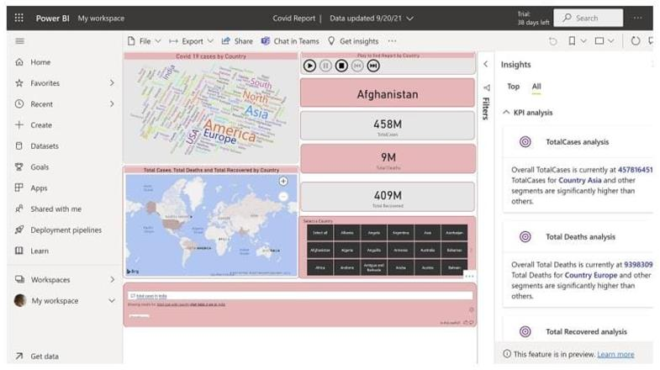

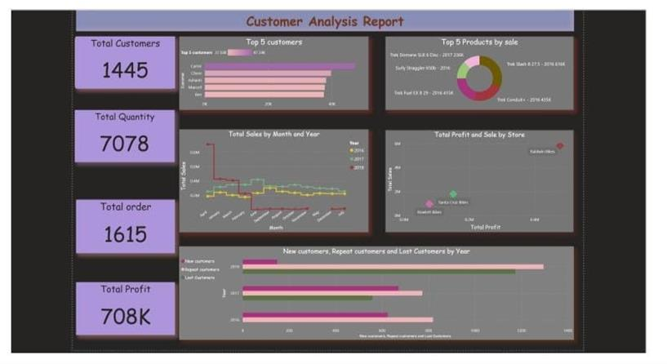

1. **Testing :**
   1. **Test cases:**

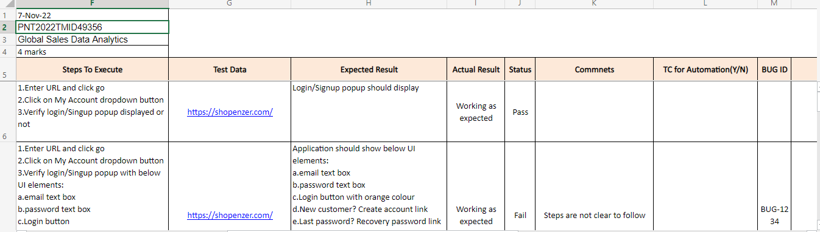

* 1. **USER ACCEPTANCE TESTING**

Copying and pasting screenshots of test results into Word or Excel is

very time-consuming and prone to human error. Optimize your UAT testing with automated documentation, workflow and defect management. The right tool will help you with exploratory testing and be able to document tests using a recorder for playback as needed, accelerating the process and

reducing the back-and-forth between the software development and testing teams.

# RESULTS

* 1. **PERFORMANCE Metrics:**

The analysis covered the period from 2012 to 2015, with conversion to the Brazilian currency Real BRL (R$). Some results:

* The US was the country with the highest profit.
* The country that presented the biggest loss in sales was Turkey.
* There was greater demand for Superstore products to be shipped via the standard mode.
* The Technology Category presented better results in Profit and Sales.
* The Retail segment performed better for all the years evaluated.

# ADVANTAGES

1. Cost efficiency
2. Receive full-scale services
3. Maximize presentation
4. Save time

# DISADVANTAGES

1. Risk of choosing the wrong provider
2. Lack of on-site support
3. Less control
4. Data security

# CONCLUSION

By implementing this analytics solution, the company brought their competitive and sales data reporting in-house, cut costs and increased the accuracy of their reporting and analysis. As the company moves forward with this new solution, their sales reporting costs will most likely be reduced by 50 to 70%. They are now able to analyze raw data themselves, respond more quickly to changes in market trends and perform root cause analysis to determine those shifts in the market. By securing quicker access to their data with the new solution, the company was also able to reduce the risk associated with delayed responses to changes in their markets.With the new solution, the company can now process sales reports faster than the outsourced solution, reducing turnaround time between 50% to 60%. The reporting needs of the company have been streamlined, consolidating over 10reports into the centralized dashboard solution. The company’s competitive analysis group is also able to more quickly respond to internal data requests given they have the ability to pull the information themselves. With this quicker response, the company is better able to react to changes in the market and predict opportunities for its sales force.The business also experienced an increase in the overall understanding of their sales data throughout the organization. The company now has great flexibility in the presentation of their sales and competitive data, while also being able to integrate sales data with other key data points for the organization.

# FUTURE SCOPE

Sales analytics refers to the use of technology to collect and use sales data to derive actionable insights. It is used to identify, optimize, and forecast sales. It uses different metrics and KPIs to plan an efficient sales model that generates higher revenue for the business.

**13.APPENDIX SOURCE CODE :**

from flask import Flask, render_template, request, redirect, url_for, session import ibm_db

import re

app = Flask(_name_)

hostname = '2f3279a5-73d1-4859-88f0- a6c3e6b4b907.c3n41cmd0nqnrk39u98g.databases.appdomain.cloud'

uid = 'hmf80902'

pwd = 'oHzpnV88erkd09'

driver = "{IBM DB2 ODBC DRIVER}"

db_name = 'bludb' port = '30756' protocol = 'TCPIP'

cert = "C:/Users/Prithiarun/Desktop/IBM/TEST/certi.crt" dsn = (

"DATABASE ={0};"

"HOSTNAME ={1};"

"PORT ={2};"

"UID ={3};" "SECURITY=SSL;" "PROTOCOL={4};"

"PWD ={6};"

).format(db_name, hostname, port, uid, protocol, cert, pwd)

connection = ibm_db.connect(dsn, "", "") print(dsn)

# query = "SELECT username FROM USER1 WHERE username=?" # stmt = ibm_db.prepare(connection, query)

# ibm_db.bind_param(stmt, 1, username) # ibm_db.execute(stmt)

# username = ibm_db.fetch_assoc(stmt) # print(username)

try:

conn = ibm_db.connect(dsn,"", "") print("connected to database")

except:

print("unable to connect") server = ibm_db.server_info(conn)

print("DBSNAME: ", server.DBMS_NAME) print("DBMS_VER: ", server.DBMS_VER) print("DBNAME: ", server.DB_NAME)

app.secret_key = 'a'

@app.route('/', methods=['GET', 'POST']) @app.route('/register', methods=['GET', 'POST']) def register():

msg = " "

if request.method == 'POST':

username = request.form['username'] email_id = request.form['email_id'] phone_no = request.form['phone_no'] password = request.form['password']

query = "SELECT * FROM USER1 WHERE username=?;" stmt = ibm_db.prepare(connection, query) ibm_db.bind_param(stmt, 1, username) ibm_db.execute(stmt)

account = ibm_db.fetch_assoc(stmt) if (account):

msg = "Account already exists!"

return render_template('register.html', msg=msg)

# elif not re.match(r'[^@]+@[^@]+\.[^@]+', email_id): # msg = "Invalid email addres"

# elif not re.match(r'[A-Za-z0-9+', username):

# msg = "Name must contain only characters and numbers" else:

query = "INSERT INTO USER1 values(?,?,?,?)"

stmt = ibm_db.prepare(connection, query) ibm_db.bind_param(stmt, 1, username)

ibm_db.bind_param(stmt, 2, email_id)

ibm_db.bind_param(stmt, 3, phone_no)

ibm_db.bind_param(stmt, 4, password) ibm_db.execute(stmt)

msg = 'You have successfully Logged In!!' return render_template('login.html', msg=msg)

else:

msg = 'PLEASE FILL OUT OF THE FORM'

return render_template('register.html', msg=msg)

@app.route('/login', methods=['GET', 'POST']) def login():

global userid msg = ' '

if request.method == "POST": username = request.form['username'] password = request.form['password']

query = "select * from user1 where username=? and password=?" stmt = ibm_db.prepare(connection, query) ibm_db.bind_param(stmt, 1, username)

ibm_db.bind_param(stmt, 2, password) ibm_db.execute(stmt)

account = ibm_db.fetch_assoc(stmt)

print(account) if account:

session['Loggedin'] = True session['id'] = account['USERNAME']

session['username'] = account['USERNAME'] msg = 'Logged in Successfully'

return render_template('welcome.html', msg=msg, username=str.upper(username))

else:

msg = 'Incorrect Username or Password' return render_template('login.html', msg=msg)

else:

msg = 'PLEASE FILL OUT OF THE FORM'

return render_template('login.html', msg=msg)

@app.route('/welcome', methods=['GET', 'POST']) def welcome():

if request.method == 'POST':

username = request.form['username'] print(username)

return render_template('welcome.html', username=username) else:

return render_template('welcome.html', username=username)

if "main" == _name_: app.run()

LOGIN PAGE:

<!DOCTYPE html>

<html>

<head>

<meta name="viewport" content="width=device-width, initial-scale=1">

<title> Login Page </title>

<style> Body {

font-family: Calibri, Helvetica, sans-serif; background-color:white;

background-image: url('https://2h2fxj2oochv47z6ig3v0sve-wpengine.netdna- ssl.com/wp-content/uploads/2021/07/man-in-a-suit-standing-behind-a-hologram- of-data-analytics-1030x579.jpg');"

}

button {

background-color:#c3e3dc; width: 100%;

color: purple;

padding: 15px; margin: 10px 0px; border: none; cursor: pointer;

}

form {

border: 3px solid #f156189;

}

input[type=text], input[type=password] { width: 100%;

margin: 8px 0; padding: 12px 20px; display: inline-block; border: 2px white;

box-sizing: border-box;

}

button:hover {

opacity: 0.7;

}

.cancelbtn {

width: auto; padding: 10px 18px; margin: 20px;

background-color: skyblue; border-radius: 5px;

font-weight: bold; color: black;

}

.content {

margin: 0px 20%; color: white;

}

.container {

padding: 25px;

}

.loginbtn {

background-color: skyblue; text-decoration: none; color: black;

margin-left: 30%; padding: 10px 20px; font-weight: bold; border-radius: 5px; margin-right: 20px;

}

.forgotbtn {

background-color: skyblue; text-decoration: none; color: black;

padding: 10px 20px; font-weight: bold; border-radius: 5px;

}

.aboutbtn {

background-color: skyblue; text-decoration: none; color: black;

padding: 10px 20px; font-weight: bold; border-radius: 5px; margin-right: 20px;

}

.dashboardbtn {

background-color: skyblue; text-decoration: none; color: black;

padding: 10px 20px; font-weight: bold;

border-radius: 5px;

}

.Datasetbtn{

background-color:skyblue; color:black;

padding:10px 20px; font-weight:bold; border-radius:5px;

}

</style>

</head>

<body>

<center> <h1 style="background-color:white">Login Form</h1> </center>

<form>

<div class="container content">

<label style="color: white; font-weight: bold;">Username : </label>

<input type="text" placeholder="Enter Username" name="username">

<label style="color: white; font-weight: bold; ">Password : </label>

<input type="password" placeholder="Enter Password" name="password"><br><br>

<a href="https://[www.ibm.com/in-en/products/cognos-analytics](http://www.ibm.com/in-en/products/cognos-analytics)" class="loginbtn">Login</a>

<a href="about.html" class="aboutbtn">About</a>

<a href="https://us3.ca.analytics.ibm.com/bi/?perspective=dashboard&pathRef=.publi c_folders%2FDatavisulaization%2FData%2Bvisulaization&action=view&mode=d ashboard&subView=model000001846c063c4b_00000000" class="dashboardbtn">Dashboard</a> <a href="https:/[/www](http://www.kaggle.com/datasets/apoorvaappz/global-super-store-dataset).[kaggle.com/datasets/apoorvaappz/global-super-store-dataset](http://www.kaggle.com/datasets/apoorvaappz/global-super-store-dataset)" class="Datasetbtn">Dataset</a><br><br><br>

<input type="checkbox" checked="checked" style="margin-left: 25%;">Remember me

<a href="#" class="cancelbtn">Cancel</a>

<a href="#" class="forgotbtn">Forgot password?</a>

</div>

</form>

</body>

</html>

<!DOCTYPE html>

<html lang="en">

<head>

<meta charset="UTF-8">

<meta http-equiv="X-UA-Compatible" content="IE=edge">

<meta name="viewport" content="width=device-width, initial-scale=1.0">

<link rel="stylesheet" href="[https://cdn.jsdelivr.net/npm/bootstrap@4.6.1/dist/css/bootstrap.min.css](https://cdn.jsdelivr.net/npm/bootstrap%404.6.1/dist/css/bootstrap.min.css)">

<script src="[https://cdn.jsdelivr.net/npm/jquery@3.6.0/dist/jquery.slim.min.js](https://cdn.jsdelivr.net/npm/jquery%403.6.0/dist/jquery.slim.min.js)"></script>

<script src="[https://cdn.jsdelivr.net/npm/popper.js@1.16.1/dist/umd/popper.min.js](https://cdn.jsdelivr.net/npm/popper.js%401.16.1/dist/umd/popper.min.js)"></scri pt>

<script src="[https://cdn.jsdelivr.net/npm/bootstrap@4.6.1/dist/js/bootstrap.bundle.min.js](https://cdn.jsdelivr.net/npm/bootstrap%404.6.1/dist/js/bootstrap.bundle.min.js)">

</script>

<title>About</title>

<style>

*{

margin:0px;

box-sizing: border-box;

}

body{

font-family: Arial, Helvetica, sans-serif; margin: 0;

background: #8e9eab; /* fallback for old browsers */

background: -webkit-linear-gradient(to right, #eef2f3, #8e9eab); /* Chrome 10-25, Safari 5.1-6 */

background: linear-gradient(to right, #eef2f3, #8e9eab); /* W3C, IE 10+/ Edge, Firefox 16+, Chrome 26+, Opera 12+, Safari 7+ */

}

#about{

margin-top: 50px;

}

h1{

font-size: 60px;

}

p{

font-size: 20px;

}

#cards{ padding: 30px

}

.column{ padding: 30px;

}

.card{

border: none;

box-shadow: rgba(0, 0, 0, 0.24) 0px 3px 8px;

}

button{

margin-left: 100px; margin-top: 50px;

}

#home-btn{ margin-top: 50px;

margin-left: 100px; padding:10px 30px; font-size: 30px;

}

</style>

</head>

<body>

<a href="index.html" class="btn btn-dark stretched-link" id="home- btn">Home</a>

<div class="container-fluid" id="about">

<h1>ABOUT US </h1>

<p>Who are we and what we do.</p>

<p>Resize the browser window to see that this page is responsive by the way.</p>

</div>

<h2 style="text-align:center">Our Team</h2>

<div class="container-fluid" id="cards">

<div class="row">

<div class="column">

<div class="card" style="width:400px;">

<img class="card-img-top" src="{{url_for('static', filename='avatar2.jpg')}}" alt="Card image" style="width:100%"/>

<div class="card-body">

<h4 class="card-title">K.Venkadanathan</h4>

<h5 class="title">Team Leader</h5><br>

<p class="card-text">ECE Engineer<br>Assigns tasks to members and manages the server.<br></p><br>

<p>[venkadanathank2000@gmail.com](mailto:venkadanathank2000@gmail.com)</p><br>

<a href="#" class="btn btn-primary stretched-link">See Profile</a>

</div>

</div>

</div>

<div class="column">

<div class="card" style="width:400px">

<img class="card-img-top" src="{{url_for('static', filename='avatar2.jpg')}}" alt="Card image" style="width:100%"/>

<div class="card-body">

<h4 class="card-title">V.Gowtham</h4>

<h5 class="title">Team Member 1</h5><br>

<p class="card-text">ECE Engineer<br>Does data visulaizations.<br></p><br>

<p>[gowthamvg278@gmail.com](mailto:gowthamvg278@gmail.com)</p><br>

<a href="#" class="btn btn-primary stretched-link">See Profile</a>

</div>

</div>

</div>

<div class="column">

<div class="card" style="width:400px">

<img class="card-img-top" src="{{url_for('static', filename='avatar2.jpg')}}" alt="Card image" style="width:100%">

<div class="card-body">

<h4 class="card-title">V.Nandhini</h4>

<h5 class="title">Team Member 2</h5><br>

<p class="card-text">ECE Engineer.<br>Does back end tasks.<br></p><br>

<p>[nandhini.v@nandhatech.org](mailto:nandhini.v@nandhatech.org)</p><br>

<a href="#" class="btn btn-primary stretched-link">See Profile</a>

</div>

</div>

</div>

<div class="column">

<div class="card" style="width:400px">

<img class="card-img-top" src="{{url_for('static', filename='avatar2.jpg')}}" alt="Card image" style="width:100%">

<div class="card-body">

<h4 class="card-title">A.Vignesh</h4>

<h5 class="title">Team Member 3</h5><br>

<p class="card-text">ECE Engineer.<br>Manages storage and data.</p><br>

<p>[vignesh.v@nandhatech.org](mailto:vignesh.v@nandhatech.org)</p><br>

<a href="#" class="btn btn-primary stretched-link">See Profile</a>

</div>

</div>

</div>

</div>

</body>

</html>

GITHUB : https://github.com/IBM-EPBL/IBM-Project-6337-1658826528